Question two

Explanation:

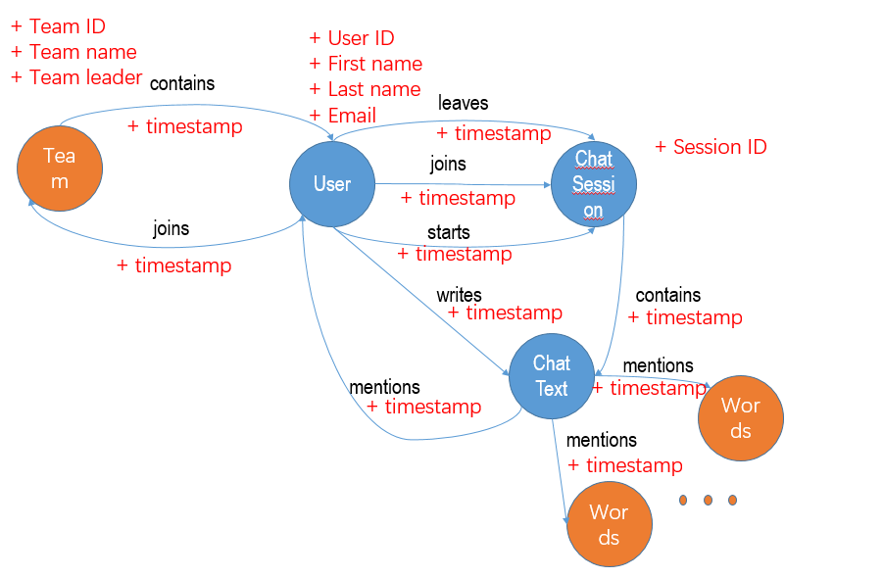

1. Which teams are having more conversations?

Users should be grouped by team to sum up the amount of conversations so entity of team should be included.

1. Do users chat more (or less) before they leave a team?

A timestamp about when user joins the team is used to distinguish the amount of the user`s chat.

1. What are the dominant terms (words) used in a chat session within a specific time period?

Nodes about words mentioned in the chat text are recorded so as to obtain frequency of each word. Using timestamp of when a chat session contains the chat text and when chat text contains certain words can determine the dominant terms (words) used in a chat session within a specific time period.

1. Which users are most active in a specific chat session?

Timestamp about when the user starts or joins and leaves the chat session and when the user writes chat text can determine the activities of users in each chat session. And then we can rank to find the most active one within a specific chat session.

1. How many chat sessions is a user participating in at the same time?

With the timestamp of when the user starts or joins and leaves a chat session we can determine whether the user is in the session at a specific time, then we sum up all the chat sessions that the user is participating in.